

T

166

0(

**E**

)(

A

6

)

T

**NATIONAL CERTIFICATE**

**STRENGTH OF MATERIALS AND STRUCTURES N6**

(8060076

)

**6**

**August**

**201**

**8**

**X**

**(**

**-**

**Paper)**

**09:00**

**–**

**12:00**

**REQUIREMENTS:**

**Hot**

**-**

**rolled**

**structural steel sections BOE 8/2**

**Th**

**is question paper consists of 5**

**pages**

**and a**

**formula sheet**

**of 3 pages**

**.**

Copyright reserved

# DEPARTMENT OF HIGHER EDUCATION AND TRAINING

**REPUBLIC OF SOUTH AFRICA**

NATIONAL CERTIFICATE

STRENGTH OF MATERIALS AND STRUCTURES N6

TIME: 3 HOURS

MARKS: 100

**INSTRUCTIONS AND INFORMATION**

1.

2.

3.

4.

5.

6.

Answer ALL the questions.

Questions can be answered in

any order, but sub

-

sections must be kept

together.

Draw a line after each completed sub

-

section.

Each question must be started on a NEW page.

Use

Write neatly and legibly.

T1660(**E**)(A6)T

## QUESTION 1: THICK CYLINDERS

A hydraulic cylinder with a wall thickness of 20 mm supports a vertical load which causes a maximum stress of 54 MPa in the cylinder wall. The inside diameter of the cylinder is 80 mm. Assume Young’s modulus for the material as 200 GPa and Poisson’s ratio as 0,29.

Calculate the following:

1.1 The pressure in the cylinder (5)

1.2 The mass that is supported (2)

1.3 The longitudinal stress in the cylinder wall (2)

1.4 The circumferential strain at the inside diameter (2)

1.5 The change in diameter at the inside of the cylinder (2)

**[13]**

## QUESTION 2: BENDING AND DEFLECTION

A cantilever with a length of 7 m supports a uniformly distributed load of 10 kN/m over the first 4 m from the fixed end. The deflection is limited to 13 mm and the bending stress is limited to 90 MPa.

Calculate the following:

2.1 Select the lightest suitable parallel flange I-section and state your reason (8)

2.2 The actual deflection and bending stress in the selected beam (4)

**[12]**

## QUESTION 3: COMBINED BENDING AND DIRECT STRESS

A cantilever is made up by welding two equal leg angles to form a T-shape. The beam is 4 m long and supports its own weight as well as a concentric tensile load of 180 kN.

Calculate the following:

3.1 The direct stress due to the tensile load (2)

3.2 The maximum and minimum bending stress due to its own weight in magnitude and nature (5)

3.3 The maximum and minimum resultant stresses in magnitude and nature (4)

3.4 The position of the neutral axis and then represent these values on a stress distribution diagram to indicate the position of the neutral axis (4)

## [15] QUESTION 4: RETAINING WALLS

|  |  |
| --- | --- |
| A trapezium-shaped retaining wall retains water to the top of its vertical face with a height of 4 m. The top of the wall is 1,5 m wide. The density of the wall material is 2 200 kg/m3. The maximum and minimum stresses at the toe and heel are 91,342 kPa and 38,15 kPa respectively. Consider 1 m length of the wall.    Calculate the following: |  |
| 4.1 The width of the base required | (10) |
| 4.2 The direct and bending stress values beneath the base | (4) |

**[14]**

## QUESTION 5: FORCES IN STRUCTURAL FRAMEWORKS

A shear leg has a backstay 15 m long and two legs of which each is 12 m long. The legs are placed 12 m apart and the apex of the shear leg overhangs the hinges of the legs by 6 m. The load lifted in this position is 20 kN.

5.1 Draw a side and top view of the shear leg. Use a scale of 1 cm = 3 m. (4)

5.2 Draw vector diagrams to determine the force in each leg as well as in the

backstay. Use a scale of 1 cm = 10 kN (5)

5.3 Tabulate your answers and indicate the magnitude and nature of the forces (3)

**[12]**

## QUESTION 6: REINFORCED CONCRETE

A rectangular reinforced concrete beam is 350 mm wide and the effective depth of the reinforcing is 800 mm from the top of the beam. The allowable stresses in the steel and concrete are 140 MPa and 7 MPa respectively and the modular ratio is 15.

Calculate the following:

6.1 The position of the neutral axis (2)

6.2 The maximum moment of resistance of the beam (2)

6.3 The area of reinforcing required and then select a taper flange I-profile to be used for reinforcing (3)

6.4 The actual stress in the steel (2)

6.5 The moment carried by each material (4)

**[13]**

-5- T1660(**E**)(A6)T

## QUESTION 7: TENSION IN CABLES

The roadway of a suspension bridge is 130 m long and has a weight of 3 120 kN evenly distributed over the span. The roadway is supported by two main cables which sag 8 m below the shorter pier. The piers differ 4 m in height.

Calculate the following:

7.1 The distance of the turning point from the shorter pier (2)

7.2 The minimum and maximum tensions in the cable (3)

7.3 The vertical reaction on the higher pier if the cable is attached to a saddle which is on rollers and its backstay forms an angle of 40o to the horizontal (2)

7.4 The tension in the cable at 80 m from the lower pier (3)

**[10]**

## QUESTION 8: COMBINED BENDING AND TWISTING OF SHAFTS

A hollow shaft has an outside diameter of 100 mm and a bore of 75 mm. The yield stress in shear for the material is 200 MPa. The shaft is subjected to combined twisting and bending, with the bending moment being three times the applied torque.

Calculate the following:

8.1 By using a safety factor of 4, the maximum allowable bending moment and torque (6)

8.2 The principal stress in the shaft (3)

8.3 The diameter required if the shaft must be solid (2)

**[11]**

**TOTAL:**  **100**

## STRENGTH OF MATERIALS AND STRUCTURES N6

### **FORMULA SHEET**

Any applicable equation or formula may be used.

|  |  |
| --- | --- |
| *b*  *R* *a* 2  *x* | *b*  *H* *a* 2  *x* |

 



**********

*pi* *d*2 *L*  (*D*2 *d*2)

4 4

*L*

*D*

*p*

*F*

*c*

*c*

❐

❍

❍



*E*

*R*

*H*

⬧

■

⬧

−





]

[

*R*

*H*

*E*

*d*

*d*

⬧

■

⬧



−





























−

−













−





2

2

2

1

1

1

*E*

*E*

*D*

*d*

*RC*

*H*

*RC*

*H*

*c*

⬧

■

⬧

⬧

■

⬧

]

[

2

1

*H*

*H*

*c*

*E*

*D*

*d*

⬧

⬧

−





**********

*L*

*b*

*a*

*W*

*M*



*I*

*E*

*L*

*W*

2

2



❑

*I*

*E*

*L*

*W*

3

3





*L*

*W*

*M*



*I*

*E*

*L*

*w*

6

3



❑

*I*

*E*

*L*

*w*

8

4





*I*

*E*

*L*

*W*

16

2



❑

*I*

*E*

*L*

*W*

48

3





*I*

*E*

*L*

*w*

24

3



❑

*I*

*E*

*L*

*w*

384

5

4





8

2

*L*

*w*

*M*



*wL*2

*M* 

2

*W L*

### *M* 

4

Please turn over

2*V*

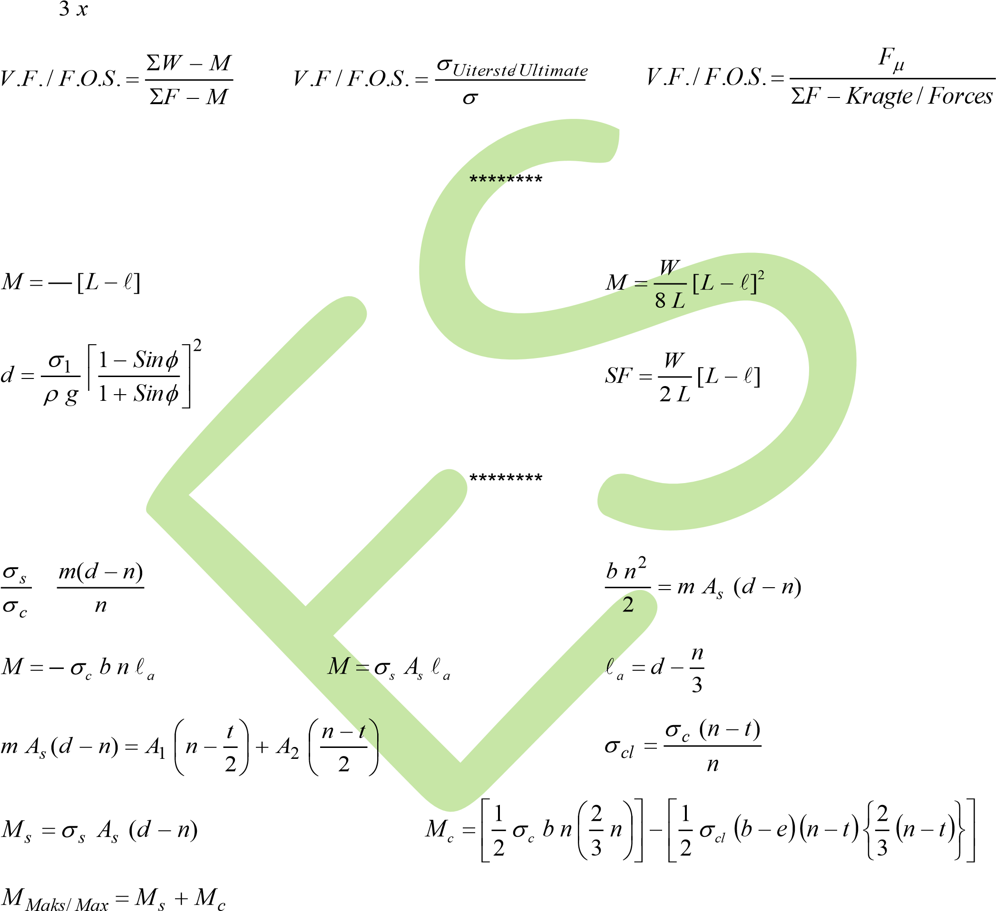*r*  (*x=afstand vanaf toon/distance from toe*)

*Mak*/*Max*

*W*

8



|  |  |  |
| --- | --- | --- |
|  |  |  |
| 1  *Fw*  *gH*2  2 | 1  *Fg*  *C**gH*2  2 | *Fp* *C* *pH* |
| 1  *C*  *Sin*  1 *Sin* | *Vx**F**M* *W* *M* | *V* 6*V e* *r*   *B*2  *B* |



1

2

********

Please turn over

|  |  |  |
| --- | --- | --- |
| *FT* *wy* | *FH* *wy*0 | *FV* *w* |
| *y*2 *y*02 2 | *FT*2 *FH*2 *FV*2 | *y x* *yo* ln  *y**o*   |
| *FV* *wx* | *wL*2  *FH*   8*d* | 8*d*2  *L*  3*L* |
| *wx*2 | *w*(*L**x* )2 |  |

#### 1 *F*  1

*d*

*F*

*H*

2



*H*

1

2

1

1

*x*





●

)

(

3

)

(

2

)

(

1

2

1

2

*x*

*L*

*h*

*d*

*x*

*L*

−





−



●

*Va*

*Vc*

*F*

*F*

*R*









*H*

*F*

*F*

*M*

*Ha*

*Hc*

−



********



















2

2

2

1

*T*

*M*

*M*

*M*

*e*

*n*

*e*

*D*

*M*

⬧

❐

32

3



2

2

*T*

*M*

*T*

*e*





⧫

❐

16

3

*D*

*T*

*e*



*D*

*d*

*D*

*D*

4

4

3

with

met

Replace

Vervang

−

2(*d* *h*)

2*d*

3 *x*